**PROJECT**

**ENTERPRISE NETWORK DESIGN AND IMPLEMENTATION IN CISCO PACKET TRACER**

**PROBLEM STATEMENT**

1. An ISP granted a block of IP address starting with **202.195.32.0/24** to an enterprise. Enterprise having 2 virtual subnet, 2 physical subnet and 4 links. Number of hosts required in different subnets are:
   1. Network A = 30 host
   2. Network B = 30 host
   3. Network C = 60 host
   4. Network D = 12 host
2. Distribute the IP address to different subnets and links by subnetting IP block granted by ISP. Use a different IP for link between Enterprise Router and ISP Router (e.g. **200.10.10.0/30**).
3. Create 2 Virtual Network A and B. Implement Inter VLAN Routing between VLANs.
4. Connect a DHCP server in Network A and configure DHCP relay in router to allow automatic IP configuration in Network B. Connect another DHCP server in Network C. Use static IP in Network D.
5. Implement Dynamic routing protocol for routing within enterprise network and default routing to connect with ISP.
6. Implement webserver, FTP server and DNS Server in network D.
7. Restrict host of Network A from exiting the network. Host of Network C should not able to access web server but can connect with internet. Hosts of Network B should not able to access internet.

**NETWORK DIAGRAM VIEW**

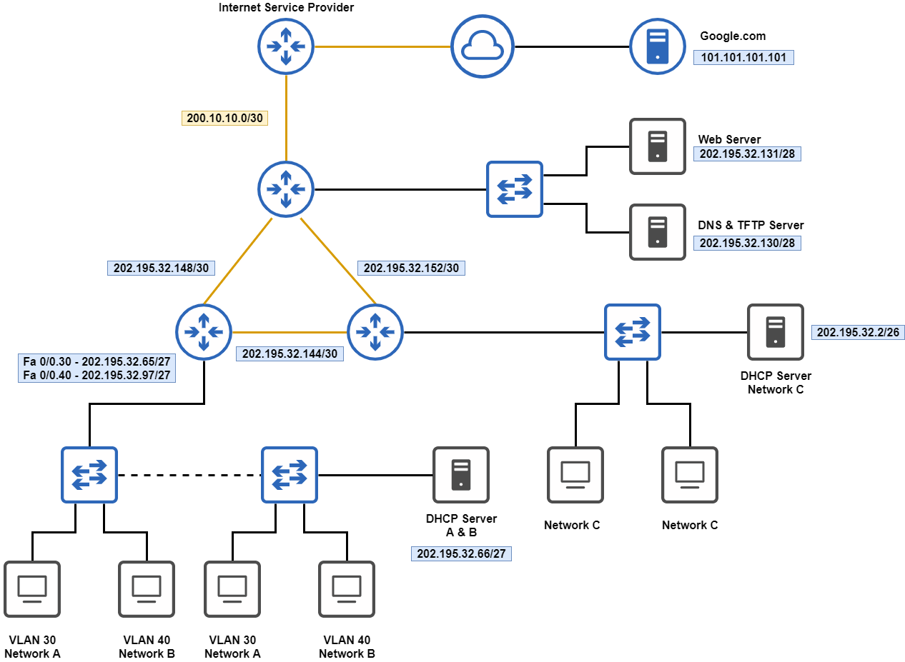

**IP ADDRESS SUBNETS**

|  |  |  |
| --- | --- | --- |
| **NAME** | **NETWORK ADDRESS** | **SUBNET MASK** |
| **Network A** | 202.195.32.64 | 255.255.255.224 |
| **Network B** | 202.195.32.96 | 255.255.255.224 |
| **Network C** | 202.195.32.0 | 255.255.255.192 |
| **Network D** | 202.195.32.128 | 255.255.255.240 |

**Dynamic IP Allocation using DHCP**

**DHCP Server at Network A**

* Server at Network A location will assigning dynamic IP address to VLAN 30 and VLAN 40 hosts respectively.
* Below pictures shows the two DHCP pools in server. First, **serverPool** assigns the IP addresses to the Network A (VLAN 30) hosts, second, **network-B** pool assigns hosts those are in Network B (VLAN 40).

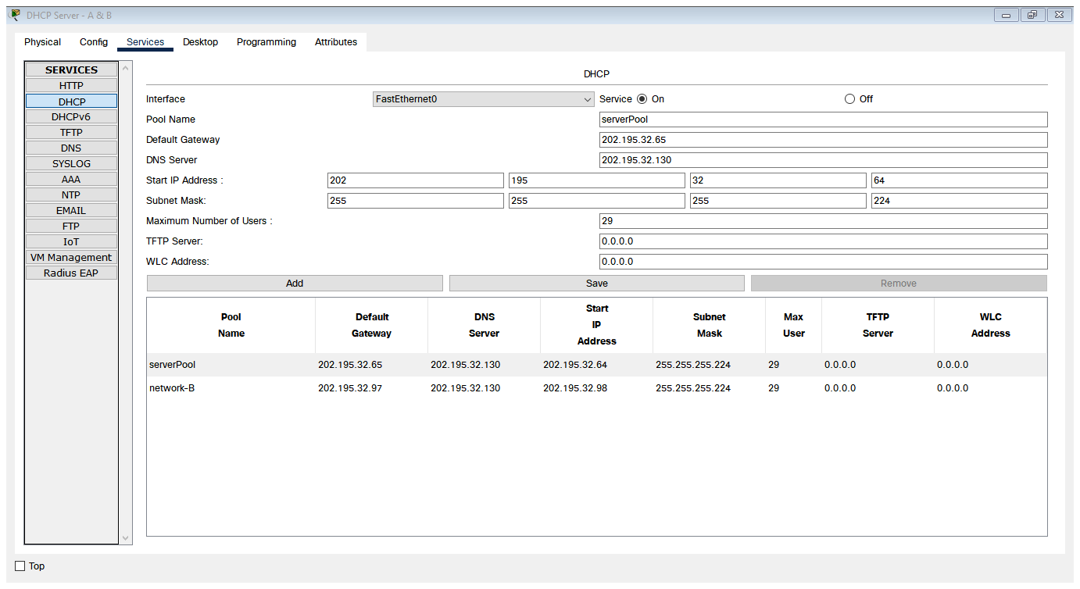

**DHCP Server at Network C**

* Server at Network A location will assigning dynamic IP address to VLAN 30 and VLAN 40 hosts respectively.
* Below pictures shows the two DHCP pools in server. First, **serverPool** assigns the IP addresses to the Network C hosts.

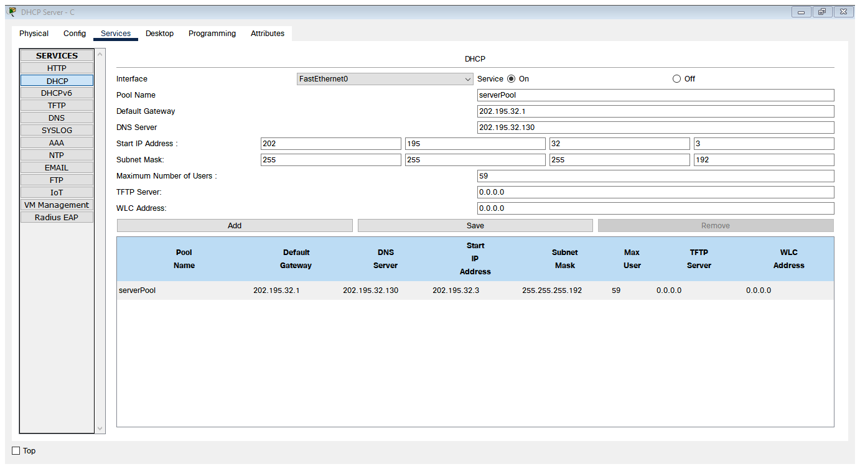

**IP ADDRESSES**

|  |  |  |  |  |
| --- | --- | --- | --- | --- |
| Device | Interface | IP Address | Subnet Mask | Gateway |
| Router 1 | FastEthernet 0/0.30  FastEthernet 0/0.40  FastEthernet 4/0  FastEthernet 5/0 | 202.195.32.65  202.195.32.97  202.195.32.149  202.195.32.145 | 255.255.255.224  255.255.255.224  255.255.255.252  255.255.255.252 | --  --  --  -- |
| Router 2 | FastEthernet 1/0  FastEthernet 4/0  FastEthernet 5/0 | 202.195.32.1  202.195.32.146  202.195.32.154 | 255.255.255.192  255.255.255.252  255.255.255.252 | --  --  -- |
| Router 3 | GigabitEthernet 7/0  FastEthernet 4/0  FastEthernet 5/0 | 200.10.10.1  202.195.32.150  202.195.32.153 | 255.255.255.252  255.255.255.252  255.255.255.252 | --  --  -- |
|  |  |  |  |  |
| DHCP Sever  Network A | FastEthernet 0 | 202.195.32.66 | 255.255.255.224 | 202.195.32.65 |
| DHCP Server  Network C | FastEthernet 0 | 202.195.32.2 | 255.255.255.192 | 202.195.32.1 |
| Web Server | FastEthernet 0 | 202.195.32.131 | 255.255.255.240 | 202.195.32.129 |
| DNS & TFTP | FastEthernet 0 | 202.195.32.130 | 255.255.255.240 | 202.195.32.129 |

**VLAN TEST PLAN**

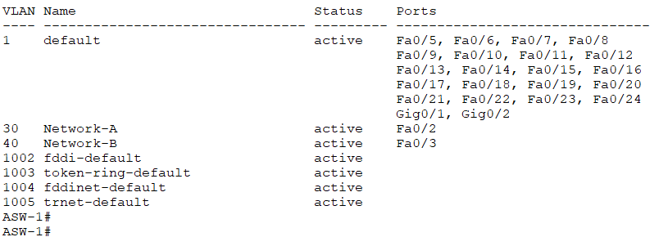

*(Fig. VLAN brief in ASW1)*

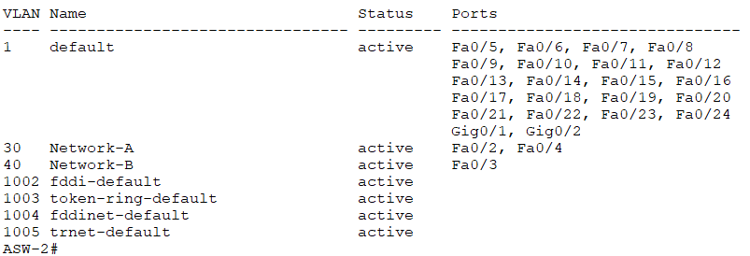

*(Fig. VLAN brief in ASW2)*

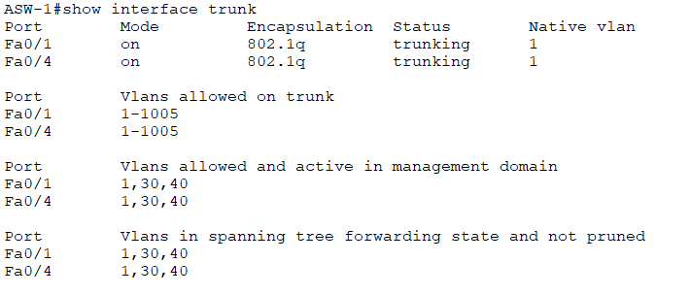

*(Fig. Trunk interfaces in ASW1)*

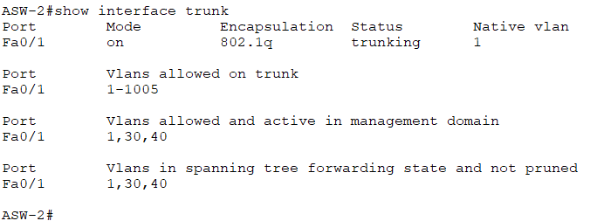

*(Fig. Trunk interface in ASW2)*

**Open Shortest Path First (OSPF)**

In order to communicate between host devices on different networks there must be a network protocol. Hence OSPF protocol is used here for this purpose to do the internal routing. The following show the utilization of OSPF in project.

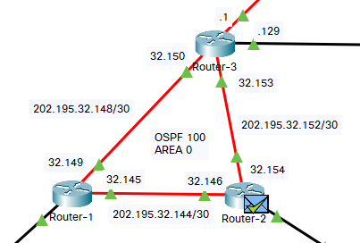

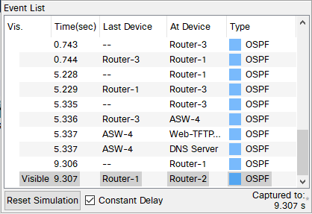

“OSPF” mentioned while carrying out simulation between inter - network

**ACCESS-LIST (SECURITY):**

To provide access control or security for the organization, we used access control list to Restrict host of Network A from exiting the network. Host of Network C should not able to access web server but can connect with internet. Hosts of Network B should not able to access internet.

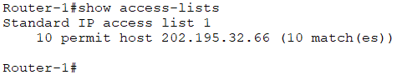

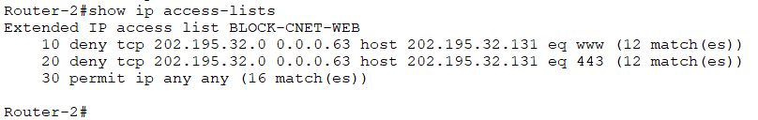

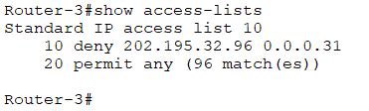

**SECURITY TEST PLAN**

A host on Network A unable to exit the network. So it cannot ping the host that is present in Network B. The ACL restricting, so router tells: Destination host unreachable.

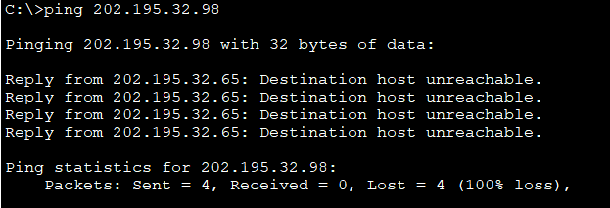

A host on Network C unable to access the Web server at 202.195.32.131 (jaugada.com). Below picture shows the output.

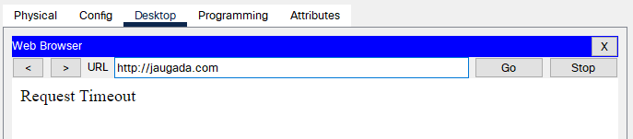

**LET’S TRY TO ACCESS THE INTERNET**

**Access Google from Network C**

When internal host wants to reach outside the network or access the internet, the traffic will be sent out the default static route which is configured on the Router 3 interface, which then send out to the ISP.

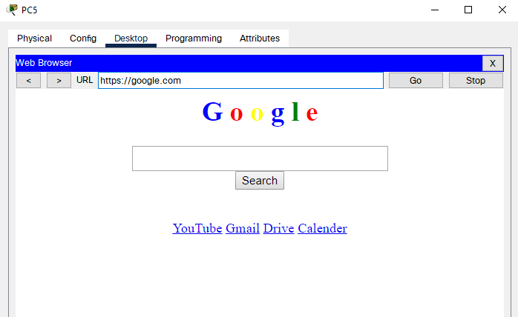

**Access Amazon from Network C**

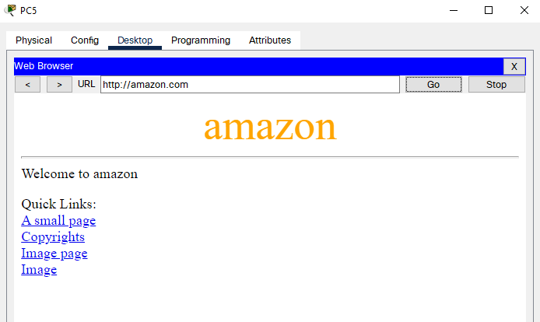

**CONCLUSION**

Thus an enterprise network was built successfully with Cisco Packet Tracer implementing various network protocols and output was tested successfully.

**Thank You!**

**Papu Sethi**

**Network Engineer**

**B.Tech in CSE**